IEEE Paper for a Biometric Voting System

Grant T Tsikisayi1

*Department of Software Engineering, Harare Institute of Technology*

H190306z@hit.ac.zw

***Abstract*- With the proposed model, a voter's vote can be counted using fingerprints. IOT technology will be used to connect the voting gadget to the system. Given that each person's fingerprints have a distinct pattern, the system uses them to uniquely identify voters. It would therefore be superior to the voting systems in use today. A voter's fingerprint is input into the system during an election. The records that are present in the database are then compared to this. Voting privileges are made available if the specific pattern matches anyone in the database. However, permission to cast a vote is refused or the vote is rejected if the pattern does not match the database records or if there is repetition. Data is transferred to the primary host through a network that connects each and every voting machine. The outcome is immediate, and the final counting is done on the primary host. Both the overall cost of holding elections and the cost of keeping the systems maintained decrease. By taking into account existing electoral procedural practices, this model is suggested. So switching to this system may be extremely simple.**

# INTRODUCTION

Personal attributes are measured and analyzed using biometrics technologies. These traits can be used to identify someone and confirm identity. Examples include fingerprints, voice patterns, hand sizes, irises, and others. These traits or biometrics are inextricably linked to an individual and cannot be lost, transferred, taken, or easily compromised. Due to the fact that personal biometrics cannot be easily stolen and a person does not need to learn codes or passwords, these traits can uniquely identify a person, replacing or enhancing conventional security measures. Due to the ease with which passwords and pins can be cracked, biometric identification offers you an alternative and greater level of protection. Applications and systems for corporate and public security are increasingly using biometric verification for authentication. I suggest using a biometric voting system based on fingerprints for the general electorate. Using registered fingerprints as a basis, the system records votes. It is an interactive GUI designed to increase productivity and automate organizational processes. The automated process of determining whether two sets of human fingerprints match is known as fingerprint authentication.

# LITERATURE SUREVEY

In [1] an electric voting machine was constructed in India for achieving a fair election system and also to shrink the man power requirements during the elections. In modern era, these electronic voting machines are prone to tampering and electoral frauds which introduces prime challenges for fair election process. However, the prospect of tampering memory chip and double voting are the two main vulnerabilities in this current voting system. Hence, it is essential to modernize the conventional voting systems with a transparent authentication module, security and reliability in order to achieve fairness in the elections. In this work a fingerprint authentication for the voter based on stored data was proposed which enables identification of individuals with high degree of accuracy and GSM feature enhances the transparency of election. Whenever, a fake vote has been casted, and then an alert message for the candidate has been sent to registered mobile number of a voter. The proposed voting system based on Arduino is trustworthy in terms of security, reliability, fairness and transparency of election.

In [2] an electronic voting system (Demotek) was proposed. It is a multi-agent prototype for an electronic voting system based on optical character recognition technology. Trade-offs in voter training, ease of use, security, and coercion across various systems are considered for the purpose of recognizing achievable improvements. Based on the use of N-version programming techniques, they proposed improvements to Demotek, including those in security and new capabilities. This case study demonstrates how the voter's authentication system and vote data transmission could further simplify and improve the electoral process by adding these new capabilities to the electronic voting system using N-version programming.

In [3] a voting system was proposed which uses a peer-to-peer network that is less vulnerable to hacking and manipulation while also being significantly more efficient. The proposed solution is divided into 3 phases and the entire process is transparent and tamper proof. The implementation costs are low, and the votes can be counted in real time. Another benefit is that, the results can be released the same day as the voting. The above-mentioned digital elections are performed using peer-to-peer technology, which makes the entire voting process more secure and reliable.

In [4] an electronic voting system based on blockchain that tackles some of the drawbacks and limitations of current systems and assesses some of the well-known blockchain frameworks in order to build a blockchain-based e-voting system. Blockchain has built-in security features. Basic concepts in blockchain include cryptographic, decentralized, and consensus concepts that guarantee integrity. It's been extremely difficult for a very long time to create a safe and secure electronic voting system that gives the clarity and versatility provided by electronic systems, as well as the transparency and privacy supplied by present voting systems. In this research work, blockchain application is assessed for implementing decentralized electronic voting systems.

In [5] they present the interfacing of online and offline voting systems with an E-Voting website. As per the bylaw of the Constitution of India, the Election Commission of India (ECI) has been driven to conduct elections honestly and autonomously at regular intervals. For this, from the last decade onwards they are implementing advanced technologies in the election process to ensure efficacy, less time consumption, and cost. Right now, the ECI effectively utilizing the Voter-Verified Paper Audit Trail (VVPAT) with an Electronic Voting Machine (EVM) to ensure each individual votes. However, still, the ECI struggling to control malpractice that exists in the election process while verifying voters with an electoral list. To overcome these issues, a face recognition device is embedded with the EVM. The ECI trying to achieve a more than ninety-five percent polling rate in a democratic country. At present, the average polling rate in all types of elections has not reached a mere seventy percent. The ECI is unable to achieve its target due to people migrating from state to state and abroad for employment. The main objective of interfacing online and offline voting systems are to provide opportunities for migrated people to complete vote during elections in their respective constituencies. In this regard, an online website is used for voting which can update the information of voters and their voting status which are acquired through both online and offline voting. The offline voting system implements the usage of the raspberry pi for face recognition. Test results on developed online and offline voting systems with an E-Voting website are found to be satisfactory.

# METHODOOGY

## System Architecture

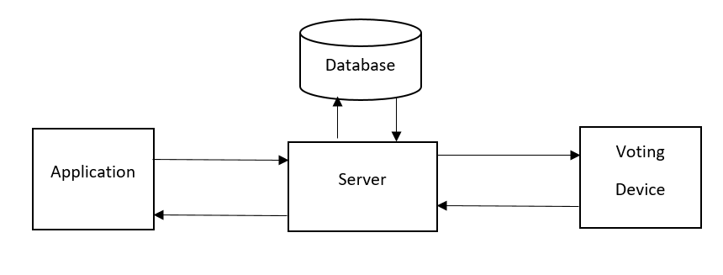

Fig 3.1

## Voting Device

The fingerprint module, Esp8266 microcontroller, LCD, and buttons will all be integrated onto a breadboard to create the voting gadget. The following section will give a thorough explanation of the components that will be used.

Breadboard

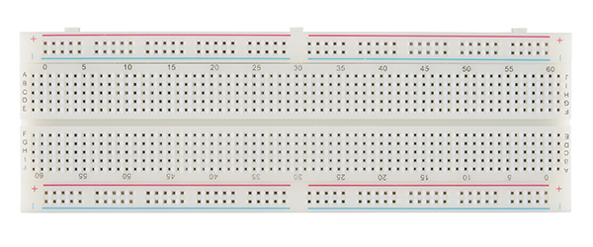

Fig 3.2

[A breadboard is a construction base used to build semi-permanent prototypes of electronic circuits**1**](https://en.wikipedia.org/wiki/Breadboard). [It allows you to place components and connections on the board to make circuits without soldering](https://www.circuitbread.com/ee-faq/what-is-a-breadboard). [Breadboards do not require soldering or destruction of tracks and are hence reusable](https://en.wikipedia.org/wiki/Breadboard). [They are popular with students and in technological education](https://en.wikipedia.org/wiki/Breadboard). All the electrical components would be connected through this breadboard.

## Fingerprint Module

A fingerprint module is a biometric sensor that captures an image of a fingerprint and compares it to a stored record to verify or identify an individual. To integrate a fingerprint module, you will need to connect it to your microcontroller board (such as Arduino) and write code to interface with the sensor.

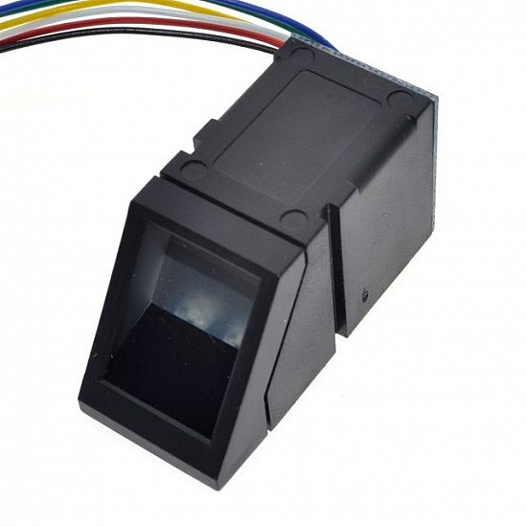

Fig 3.3

This fingerprint module is going to be responsible scaning fingerprints during registration and voting.

## Esp8266

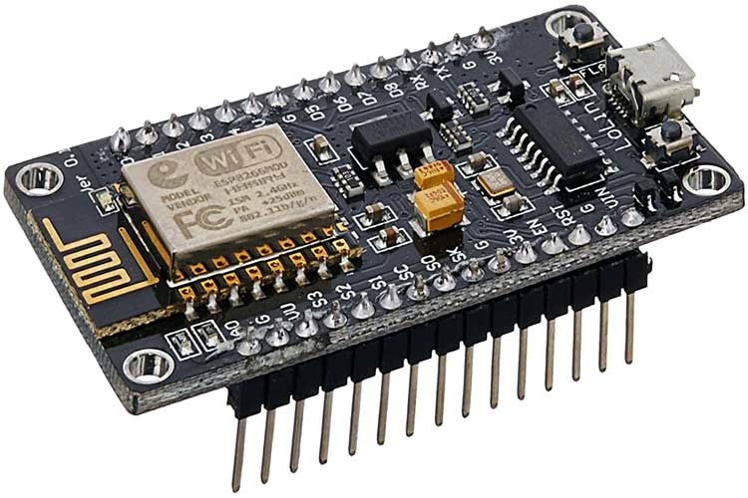

Fig 3.4

The ESP8266 is a low-cost Wi-Fi microchip, with built-in TCP/IP networking software, and microcontroller capability. It is produced by Espressif Systems in Shanghai, China. The chip was popularized in the English-speaking maker community in August 2014 via the ESP-01 module, made by a third-party manufacturer Ai-Thinker.

The ESP8266EX microcontroller integrates a Tensilica L106 32-bit RISC processor, which achieves extra-low power consumption and reaches a maximum clock speed of 160 MHz The Real-Time Operating System (RTOS) and Wi-Fi stack allow about 80% of the processing power to be available for user application programming and development³. The ESP8266 is a 3.3V microcontroller, so its I/O operates at 3.3V as well¹. The pins are not 5V tolerant, applying more than 3.6V on any pin will kill the chip. The maximum current that can be drawn from a single GPIO pin is 12mA.

The ESP8266 is going to be programmed via Arduino UNO IDE to capture fingerprints and enable a voter to cast the vote. It is the brain of the voting device. It has built-in TCP/IP networking software and microcontroller capability which enables it to connect to other devices in a network.

## LCD

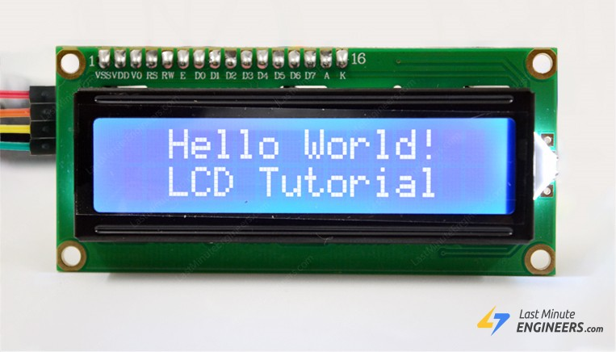

Fig 3.5

This LCD is going to be responsibe for showing the responses during registration and voting.

## Buttons

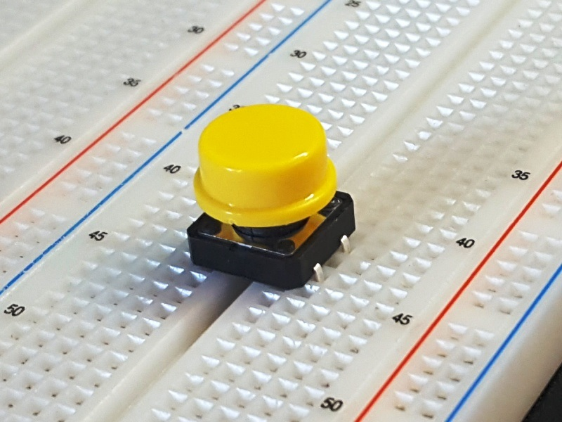

Fig 3.6

These buttons are going to be used to select a party during the voting process. They are going to be labeled according to the party names.

## Biometric Voting System Application

The system interface is going to be made by the c# using the sharp development IDE programming language. It is going to be a desktop application which will allow the admin to:

* Register a voter
* Update Registration Record
* Verify a voter’s details
* View Results
* Generate Reports
* Printing Reports

## C#

C# is a modern, object-oriented programming language developed by Microsoft. It was designed to be simple, modern, general-purpose, and type-safe. C# is used to develop applications for Microsoft’s .NET platform. It is also used for developing Windows desktop applications, games, mobile apps, and web applications. It is also used for developing enterprise-level applications and cloud-based services. C# is similar to Java in syntax and structure, but it has some unique features that make it stand out as a programming language.

## Sharp Development

SharpDevelop is a free and open-source integrated development environment (IDE) for C# and VB.NET programming languages. It provides a powerful code editor, debugger, and other features that help developers write and debug code more efficiently. SharpDevelop is available for Windows operating systems and supports .NET Framework versions 2.0 through 4.5.

## Server

The server is going to be responsibe for moving information to and fro from the MySQL database. The Xampp platform and php programming Language is going to be used to achieve this.

## Xampp

XAMPP is a free and open-source cross-platform web server solution stack package developed by Apache Friends, consisting mainly of the Apache HTTP Server, MariaDB database, and interpreters for scripts written in the PHP and Perl programming languages. XAMPP stands for Cross-Platform (X), Apache (A), MariaDB (M), PHP (P) and Perl (P).

## Apache Server

Apache HTTP Server is a free and open-source cross-platform web server software that powers around 40% of all websites on the internet. It is developed and maintained by an open community of developers under the Apache Software Foundation. Apache HTTP Server is available for Windows, Linux, and macOS operating systems and supports a wide range of features such as SSL/TLS encryption, virtual hosting, URL rewriting, and more.

## MySQL

MySQL is an open-source relational database management system (RDBMS) that uses Structured Query Language (SQL) for managing and manipulating data stored in databases. MySQL is used by many web applications and is available for Linux, Microsoft Windows, Mac OS X, and Solaris operating systems. MySQL comes with many web hosting packages and can be downloaded from the official website.

## PHP

PHP (recursive acronym for PHP: Hypertext Preprocessor) is a server-side scripting language that allows web developers to create dynamic content that interacts with databases. PHP is used for developing web-based software applications and can be embedded into HTML. PHP is a widely-used, free, and efficient alternative to competitors such as Microsoft's ASP.

## Processes

### Registration Flow Chart

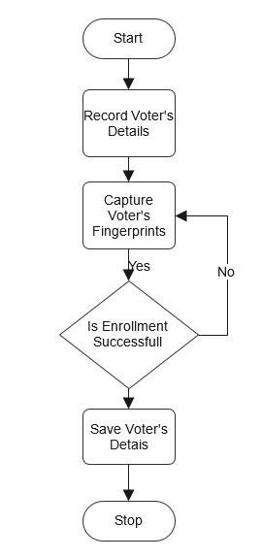

Fig 3.7

### Voting Flow Chart

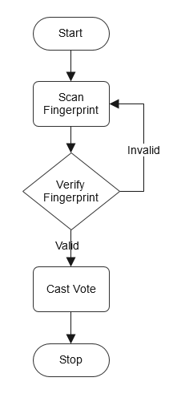

Fig 3.8

# RESULTS

## Successful registration

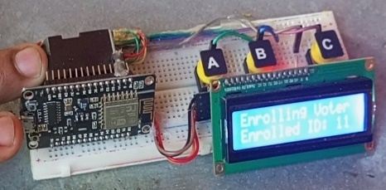

Fig 4.1

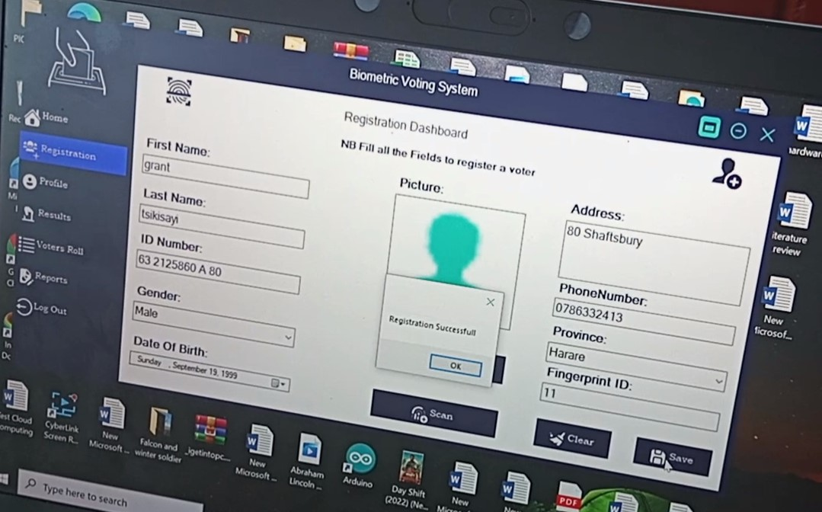

Fig 4.2

## Successful Voting

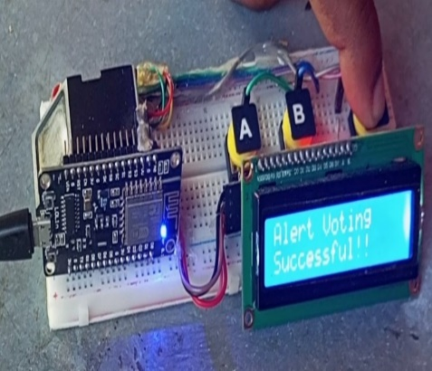

Fig 4.3

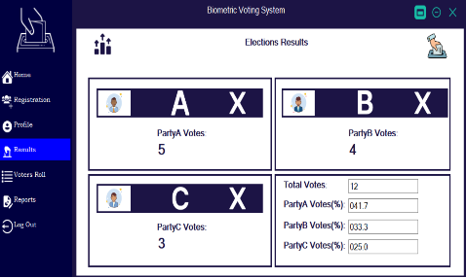

Fig 4.4

# CONCLUSION

Finger print is considered as one of the most popular biometric method used for human recognition. Every recognition in the globe is or with unique fingerprint and even twins are born with totally different finger print and is naturally unchangeable throughout the life. For that reason finger print voting system has been made and person ID has been replaced with finger print. This finger print voting system is evaluated and implemented successfully. The evaluation of the system is made using different PC’s with different specifications in order to stand on the system strength and weakness. The final result of finger print voting system is significant and compatible with other voting systems.

# REFERENCES

1. *V. R. Ch, M. V. P. A and B. S. S. A, "Arduino based Electronic Voting System with Biometric and GSM Features," 2022 4th International Conference on Smart Systems and Inventive Technology (ICSSIT), Tirunelveli, India, 2022, pp. 685-688, doi: 10.1109/ICSSIT53264.2022.9716452.*
2. *(2) I. Goirizelaia, T. Selker, M. Huarte and J. Unzilla, "An Optical Scan E-Voting System based on N-Version Programming," in IEEE Security & Privacy, vol. 6, no. 3, pp. 47-53, May-June 2008, doi: 10.1109/MSP.2008.57.*
3. *A. Joseph, S. George and R. K. Samuel, "A P2P Digital Voting System for Elections in India," 2022 International Conference on Computing, Communication, Security and Intelligent Systems (IC3SIS), Kochi, India, 2022, pp. 1-5, doi: 10.1109/IC3SIS54991.2022.9885353.*
4. *S. Singh, A. Singh, S. Verma and R. K. Dwivedi, "Designing a Blockchain-Enabled Methodology for Secure Online Voting System," 2023 International Conference on Intelligent Data Communication Technologies and Internet of Things (IDCIoT), Bengaluru, India, 2023, pp. 178-184, doi: 10.1109/IDCIoT56793.2023.10053410.*
5. *N. Keerthi, A. Raghuram and R. Jayaraman, "Interfacing of Online and Offline Voting System with an E-Voting Website," 2022 6th International Conference on Devices, Circuits and Systems (ICDCS), Coimbatore, India, 2022, pp. 223-228, doi: 10.1109/ICDCS54290.2022.9780681.*
6. Getting Started with ESP8266 NodeMCU ... - Random Nerd Tutorials. <https://randomnerdtutorials.com/getting-started-with-esp8266-wifi-transceiver-review/>.
7. *(Getting Started With the ESP8266 ESP-01 - Instructables.* [*https://www.instructables.com/Getting-Started-With-the-ESP8266-ESP-01/*](https://www.instructables.com/Getting-Started-With-the-ESP8266-ESP-01/)*.*
8. *NTRODUCTION TO ESP8266 module - Microcontrollers Lab.* [*https://microcontrollerslab.com/esp8266-getting-started-tutorial/*](https://microcontrollerslab.com/esp8266-getting-started-tutorial/)*.*
9. *GitHub - esp8266/Arduino: ESP8266 core for Arduino.* [*https://github.com/esp8266/Arduino*](https://github.com/esp8266/Arduino)*.*
10. *adafruit/Adafruit-Fingerprint-Sensor-Library - Github.* [*https://github.com/adafruit/Adafruit-Fingerprint-Sensor-Library*](https://github.com/adafruit/Adafruit-Fingerprint-Sensor-Library)*.*
11. *GitHub - hkieninger/fingerprint-R503: A library for ESP8266 (Arduino ....* [*https://github.com/hkieninger/fingerprint-R503*](https://github.com/hkieninger/fingerprint-R503)*.*
12. Fingerprint Sensor Module with Arduino | Random Nerd Tutorials. https://randomnerdtutorials.com/fingerprint-sensor-module-with-arduino/.
13. Fingerprint Sensor Modules – Mouser. https://www.mouser.com/c/embedded-solutions/sensor-modules/fingerprint-sensor-modules/.
14. Fingerprint Sensor Modules – Mouser India. https://www.mouser.in/c/embedded-solutions/sensor-modules/fingerprint-sensor-modules/.
15. SQL vs. MySQL: Differences, Similarities, Uses, and Benefits. https://www.coursera.org/articles/sql-vs-mysql.
16. MySQL :: Download MySQL Community Server. https://dev.mysql.com/downloads/mysql/.
17. What is MySQL: MySQL Explained for Beginners - Hostinger. https://www.hostinger.com/tutorials/what-is-mysql.
18. MySQL. <https://www.mysql.com/>.
19. an-advanced-and-secured-biometric-voting-system-IJERTCONV6IS13118
20. PHP: Hypertext Preprocessor. https://www.php.net/.
21. PHP Tutorial - W3Schools. https://www.w3schools.com/php/default.asp.